Name:

ID:

Submit here: <https://docs.google.com/forms/d/e/1FAIpQLSexzsLq5mnAAthOL7JMJqhE7df-R6K1vyn3-dMr8pog4PTbWw/viewform>

Challenge 06

PART 1: [Functions](https://runestone.academy/runestone/books/published/fopp/Functions/intro-Functions.html)

1. All of the following are good reasons to break up your code into functions except:

|  |  |
| --- | --- |
| Write less code | Saves time |
| Organizes code better | Makes program more complex |

1. Which of the following is not a legal name for a function?

|  |  |
| --- | --- |
| jess | name |
| function | _0 |
| Func1 | -apple |

1. Which of the following is the keyword for making a function?

|  |  |
| --- | --- |
|  |  |
|  |  |
|  |  |

1. What is the error in the following function?

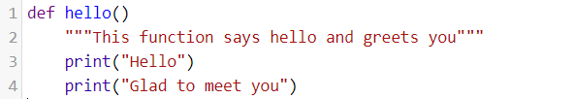

|  |  |
| --- | --- |
| Illegal name | Wrong keyword |
| Missing body | Does not return anything |
| Missing function keyword | Missing colon |

1. Which of the following gives the docstring from the hello function?

|  |  |
| --- | --- |
| hello | docstring |
| Glad to meet you | This function says hello and greets you |
| def | __doc__ |

1. Which of the following invokes or runs the hello function?

|  |  |
| --- | --- |
| hello | print(hello) |
| hello.run() | hello() |
| Invoke(hello) | call(hello) |

1. How many parameters does the following function have?

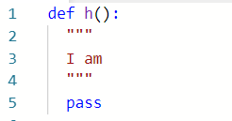

|  |  |
| --- | --- |
| 0 | 1 |
| 2 | 3 |
| 4 | 5 |
| 6 | -1 |

1. How many parameters does the following function have?

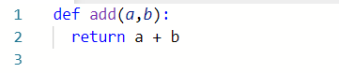

|  |  |
| --- | --- |
| 0 | 1 |
| 2 | 3 |
| 4 | 5 |
| 6 | -1 |

1. How many parameters does the following function have?

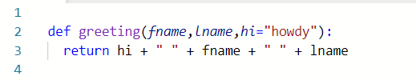

|  |  |
| --- | --- |
| 0 | 1 |
| 2 | 3 |
| 4 | 5 |
| 6 | -1 |

1. What is the output of the following?

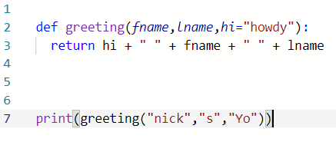

|  |  |
| --- | --- |
| nick s Yo | nick s |
| howdy nick s Yo | Yo nick s |
| Howdy nick s | nick s Yo |

1. What is the output of the following?

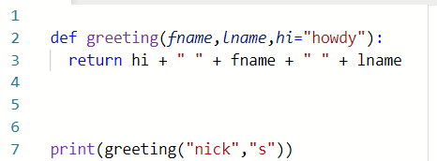

|  |  |
| --- | --- |
| nick s Yo | nick s |
| howdy nick s Yo | Yo nick s |
| Howdy nick s | nick s Yo |

1. What is the output of the following?

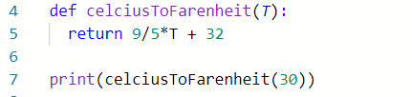

|  |  |
| --- | --- |
| 30 | 86 |
| 62 | 54 |
| 85 | 84 |

1. Which of the following is an illegal parameter name?

|  |  |
| --- | --- |
| param | var |
| parameter | keyword |
| variable | A1 |
| _0 | 0p |

1. How many times can you invoke a function?

|  |  |
| --- | --- |
| Only once | never |
| Less than 10 times | As many times as you want |
| Depends on if the function returns something | Twice |

1. Will the output of the function always be the same?

|  |  |
| --- | --- |
| Depends on the function | Yes |
| No | There isn’t output |

1. How many times is the function invoked, is the output the same each time the function is called?

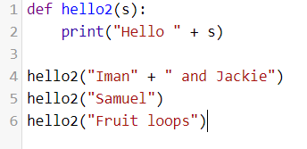

|  |  |
| --- | --- |
| 4, yes | 4, no |
| 3, yes | 3, no |
| 2, yes | 2, no |

1. Is the following function fruitful or a procedure?

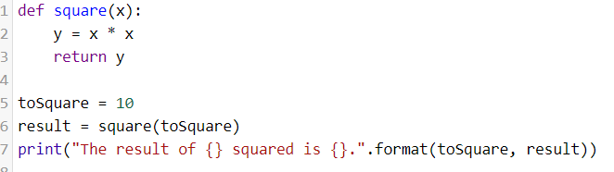

|  |  |
| --- | --- |
| fruitful | Cannot be determined |
| procedure | neither |

1. How many local variables are inside the square function?

|  |  |
| --- | --- |
| 0 | 1 |
| 2 | 3 |
| 4 | 5 |

Part 2: Challenge problems

1. Consider the following:

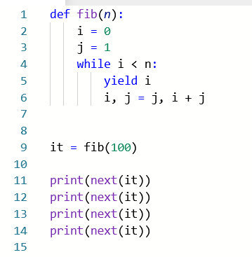

* How many times should I print **next(it)** to get the value 13?

|  |  |
| --- | --- |
| 4 | 7 |
| 6 | 8 |
| 9 | None of the above |

1. Consider the following:

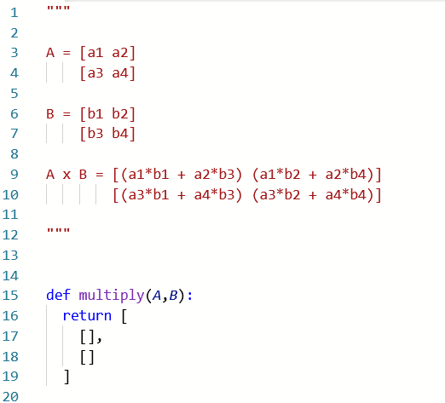

* Lines 1-12 describe how to multiply two 2x2 matrices. Complete the multiply function so that it correctly multiplies two matrices A and B. Matrices will be represented as list with two lists inside: [[],[]]. Paste a screenshot of your code below:
* Complete the following table:

|  |  |  |
| --- | --- | --- |
| A | B | A x B |
| [[1,0],[0,1]] | [[4,4],[4,1]] |  |
| [[5.22,-2.2],[2.1,-0.4]] | [[1.736,1.1229],[4.9,-1.23]] |  |
| [[0.3345,0.1113],[0.15,0.1 + 2j]] | [[0.22,0],[0.1,1]] |  |